Lab: Adding allergy information
Goal: Show why there is a need to use DTOs (Data Transfer Objects) and show how to use filters

Adding the Allergy model
In this part, we’ll add a new Entity called “Allergy” and create a many-to-many relationship with Pie: a Pie can have multiple allergy items and an allergy item can occur in multiple pies.
Steps:
- In the “Models” folder, add a new class called “Allergy”
Notice we initialize the list of Pies in the controller to avoid null reference exceptions
public class Allergy
{
public Allergy()
{
Pies = new List<Pie>();
}

public required int Id { get; set; }
public required string Name { get; set; }

public ICollection<Pie> Pies { get; set; }
}
- In the “Pie” class, add a list of “AllergyItems”
Notice we initialize the list in the controller to avoid null reference exceptions
public class Pie
{
public Pie()
{
AllergyItems = new List<Allergy>();
}

public int Id { get; set; }

[Required]
[Length(3, 50)]
public required string Name { get; set; }

[MaxLength(500)]
public required string Description { get; set; }

public ICollection<Allergy> AllergyItems { get; set; }
}
- In the PieShopDbContext, add the DbSet for Allergies, seed some data for the Allergies and add Allergy Items to some Pies
Notice we seed the Allergies and seed the relationship with Pies
public class PieShopDbContext : DbContext
{
public PieShopDbContext(DbContextOptions<PieShopDbContext> options) : base(options)
{
}

public DbSet<Pie> Pies { get; set; }
public DbSet<Allergy> Allergies { get; set; }

override protected void OnModelCreating(ModelBuilder modelBuilder)
{
modelBuilder.Entity<Allergy>().HasData(
new Allergy { Id = 1, Name = "Cow's milk" },
new Allergy { Id = 2, Name = "Eggs" },
new Allergy { Id = 3, Name = "Tree nuts" },
new Allergy { Id = 4, Name = "Peanuts" },
new Allergy { Id = 5, Name = "Shellfish" },
new Allergy { Id = 6, Name = "Wheat" },
new Allergy { Id = 7, Name = "Soy" },
new Allergy { Id = 8, Name = "Fish" },
new Allergy { Id = 9, Name = "Sesame" }
);

modelBuilder.Entity<Pie>().HasData(
new Pie { Id = 1, Name = "Apple Pie", Description = "Tasty" },
new Pie { Id = 2, Name = "Cherry Pie", Description = "Yummy" },
new Pie { Id = 3, Name = "Pumpkin Pie", Description = "Delicious" },
new Pie { Id = 4, Name = "Blueberry Pie", Description = "Scrumptious" },
new Pie { Id = 5, Name = "Peach Pie", Description = "Succulent" },
new Pie { Id = 6, Name = "Pecan Pie", Description = "Rich" },
new Pie { Id = 7, Name = "Lemon Meringue Pie", Description = "Zesty" },
new Pie { Id = 8, Name = "Key Lime Pie", Description = "Tangy" },
new Pie { Id = 9, Name = "Banana Cream Pie", Description = "Creamy" },
new Pie { Id = 10, Name = "Coconut Cream Pie", Description = "Tropical" },
new Pie { Id = 11, Name = "Rhubarb Pie", Description = "Tart" },
new Pie { Id = 12, Name = "Sweet Potato Pie", Description = "Velvety" },
new Pie { Id = 13, Name = "Blackberry Pie", Description = "Juicy" },
new Pie { Id = 14, Name = "Bumbleberry Pie", Description = "Berry-licious" },
new Pie { Id = 15, Name = "Pear Pie", Description = "Sweet" },
new Pie { Id = 16, Name = "Raspberry Pie", Description = "Tangy" },
new Pie { Id = 17, Name = "Strawberry Rhubarb Pie", Description = "Refreshing" },
new Pie { Id = 18, Name = "Mississippi Mud Pie", Description = "Decadent" },
new Pie { Id = 19, Name = "Salted Caramel Pie", Description = "Savory-sweet" },
new Pie { Id = 20, Name = "Mince Pie", Description = "Spiced" },
new Pie { Id = 21, Name = "Custard Pie", Description = "Smooth" },
new Pie { Id = 22, Name = "French Silk Pie", Description = "Luxurious" },
new Pie { Id = 23, Name = "Grasshopper Pie", Description = "Minty" },
new Pie { Id = 24, Name = "S'mores Pie", Description = "Toasty" },
new Pie { Id = 25, Name = "Margarita Pie", Description = "Zingy" },
new Pie { Id = 26, Name = "Mud Pie", Description = "Dense" },
new Pie { Id = 27, Name = "Oatmeal Pie", Description = "Hearty" },
new Pie { Id = 28, Name = "Peanut Butter Pie", Description = "Rich" },
new Pie { Id = 29, Name = "Butterscotch Pie", Description = "Buttery" },
new Pie { Id = 30, Name = "Chess Pie", Description = "Classic" },
new Pie { Id = 31, Name = "Almond Pie", Description = "Nutty" },
new Pie { Id = 32, Name = "Caramel Apple Pie", Description = "Sticky-sweet" },
new Pie { Id = 33, Name = "Maple Pie", Description = "Syrupy" },
new Pie { Id = 34, Name = "Orange Marmalade Pie", Description = "Bitter-sweet" },
new Pie { Id = 35, Name = "Fig Pie", Description = "Jammy" },
new Pie { Id = 36, Name = "Chocolate Peanut Butter Pie", Description = "Sinful" },
new Pie { Id = 37, Name = "Lime Pie", Description = "Citrusy" },
new Pie { Id = 38, Name = "Vanilla Bean Pie", Description = "Aromatic" },
new Pie { Id = 39, Name = "Mixed Berry Pie", Description = "Bursting with berries" },
new Pie { Id = 40, Name = "Espresso Pie", Description = "Coffee-flavored" },
new Pie { Id = 41, Name = "Spiced Pear Pie", Description = "Warm" },
new Pie { Id = 42, Name = "Toffee Pie", Description = "Buttery-caramel" },
new Pie { Id = 43, Name = "Plum Pie", Description = "Tart-sweet" },
new Pie { Id = 44, Name = "Mango Pie", Description = "Exotic" },
new Pie { Id = 45, Name = "Blackcurrant Pie", Description = "Intense" },
new Pie { Id = 46, Name = "Nectarine Pie", Description = "Summery" },
new Pie { Id = 47, Name = "Macadamia Nut Pie", Description = "Crunchy" },
new Pie { Id = 48, Name = "Cranberry Pie", Description = "Tangy" },
new Pie { Id = 49, Name = "White Chocolate Raspberry Pie", Description = "Velvety-rich" },
new Pie { Id = 50, Name = "Apricot Pie", Description = "Honeyed" }
);

modelBuilder.Entity<Pie>()
.HasMany(p => p.AllergyItems)
.WithMany(a => a.Pies)
.UsingEntity(p => p.HasData(
new { PiesId = 1, AllergyItemsId = 1 },
new { PiesId = 1, AllergyItemsId = 2 },
new { PiesId = 1, AllergyItemsId = 6 }
));

base.OnModelCreating(modelBuilder);

}
}
- Let’s test our GetPie method using the .http file
GET {{PieShopApi_HostAddress}}/pies/1
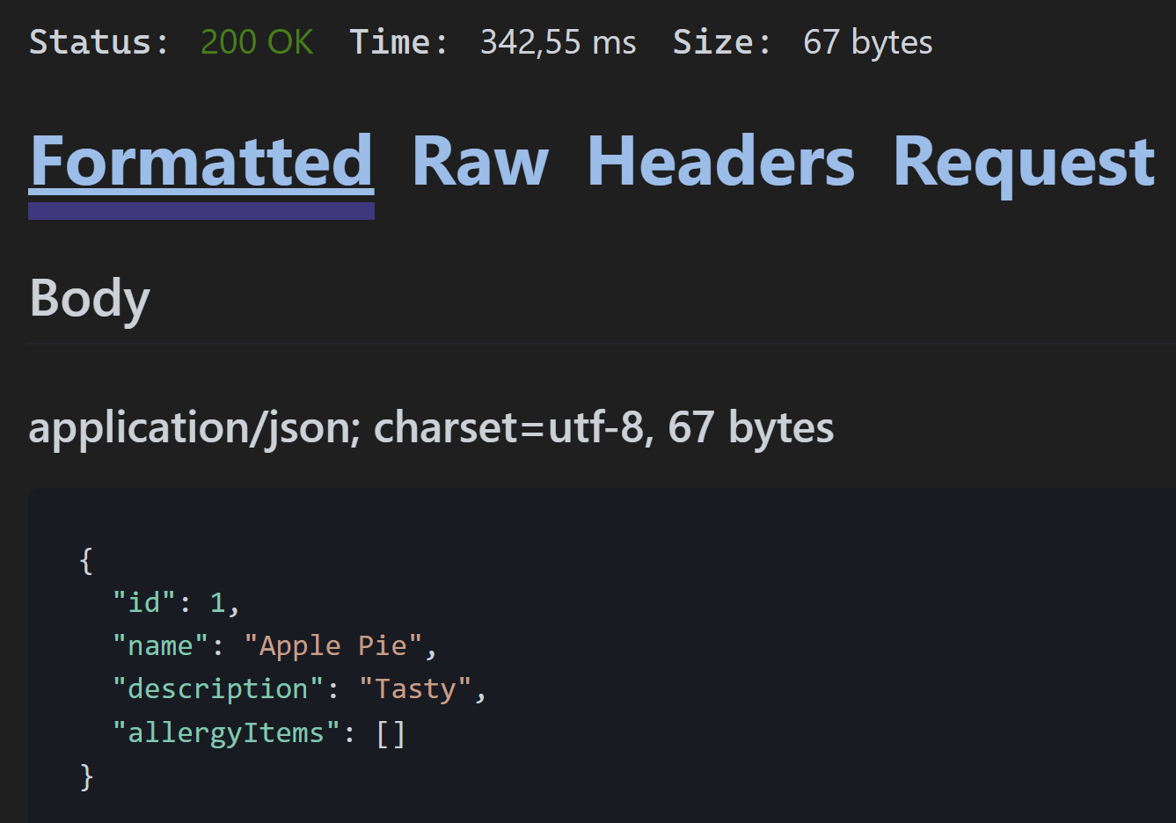
Notice our AllergyItems list is empty!
- In our PieRepository, let’s tell Entity Framework to include the AllergyItems when requesting a Pie detail. We do this by overriding the GetByIdAsync method from our generic base repository
public async override Task<Pie?> GetByIdAsync(int id)
{
Pie? pie = await _dbContext.Pies.Include(p => p.AllergyItems)
.FirstOrDefaultAsync(p => p.Id == id);

return pie;
}
- Let’s test again using the .http file
GET {{PieShopApi_HostAddress}}/pies/1
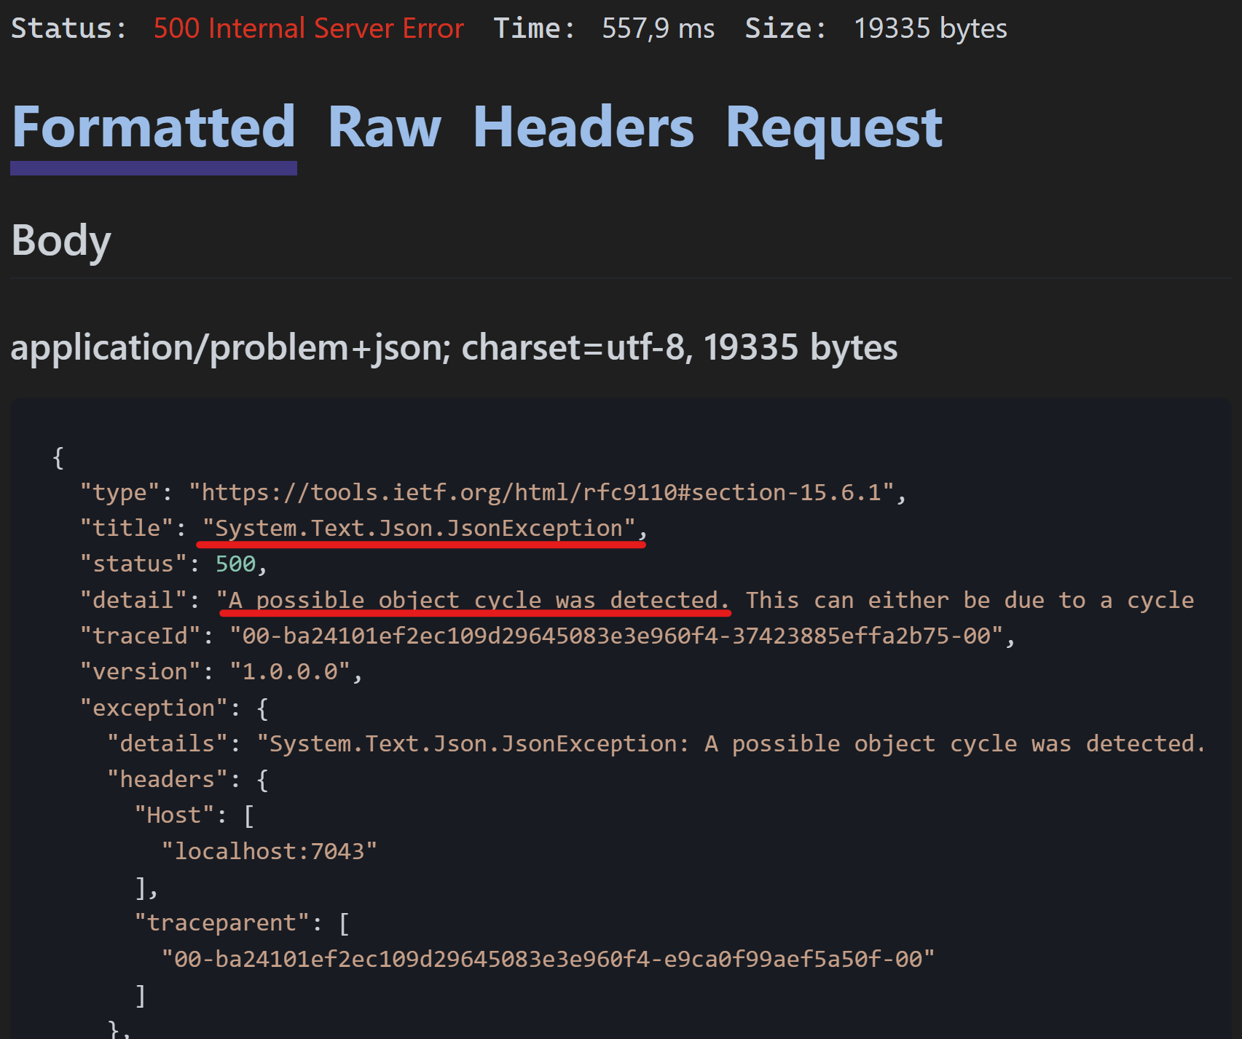
Fail! Our JSON serializer is stuck in a cyclic loop: Pie AllergyItems Pies AllergyItems …

Adding DTOs
In this part, we’ll fix the cyclic loop by using a DTO (Data Transfer Object).
By using DTOs, we encapsulate the underlying data model, by only exposing the properties we need.
Steps:
- Let’s start by brining a bit more structure in our Models Folder:
  - Move Pie.cs to a subfolder called “Pies” and adjust the namespace accordingly
  - Move Allergy.cs to a subfolder called “Allergies” and adjust the namespace accordingly
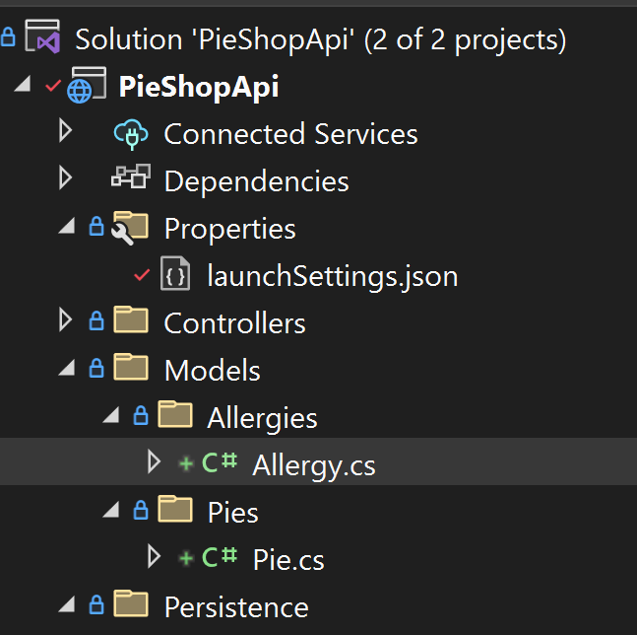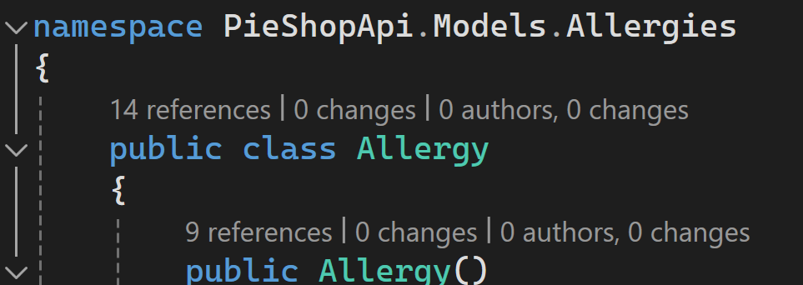
Notice we give plural names to our namespaces, to avoid naming conflicts with our Model classes
- In the Models/Pies folder, add a new class named PieDto
public class PieDto
{
public PieDto()
{
AllergyItems = new List<string>();
}
public int Id { get; set; }
public required string Name { get; set; }
public required string Description { get; set; }
public IList<string> AllergyItems { get; set; }
}
Notice that instead of returning a List of Allergy objects, we return a List of string
- In the PiesController, update our GetPie method, so that it returns the DTO instead
[HttpGet]
[Route("{id:int}")]
public async Task<ActionResult<PieDto>> GetPie(int id)
{
var pie = await _pieRepository.GetByIdAsync(id);

if (pie == null)
return NotFound();

var pieDto = new PieDto
{
Id = pie.Id,
Name = pie.Name,
Description = pie.Description,
AllergyItems = pie.AllergyItems.Select(x => x.Name).ToList()
};

return Ok(pieDto);
}
- Let’s test the change, using our .http file and verify everything works again
GET {{PieShopApi_HostAddress}}/pies/1
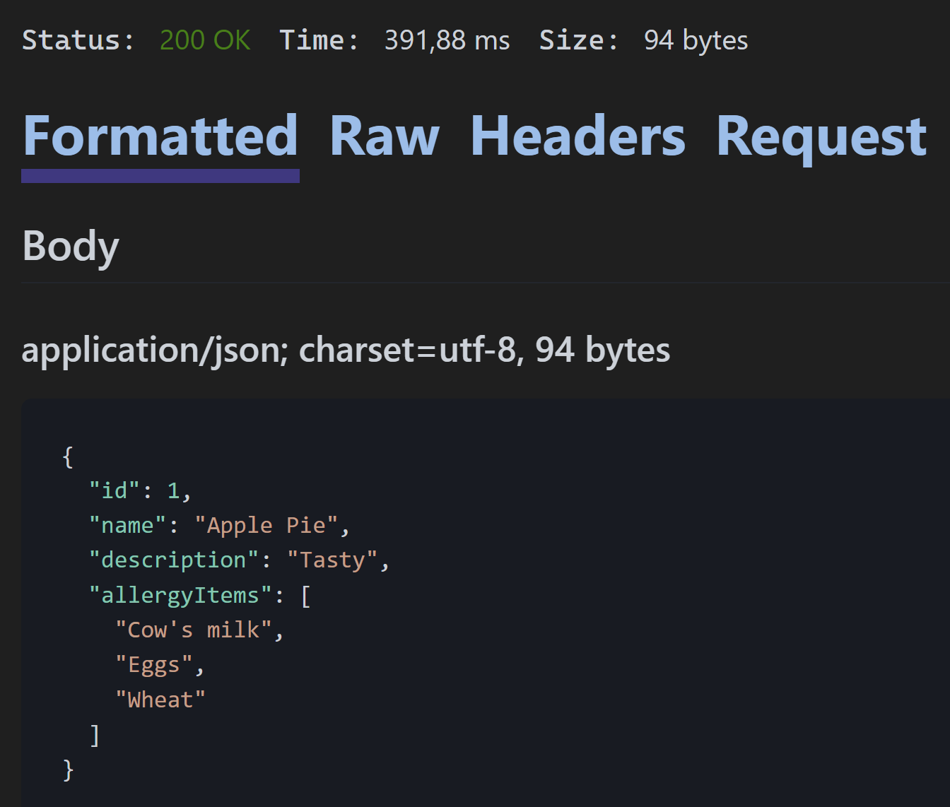
For our GetPies method, we could also return the PieDto, but we choose (business requirement) to not return the AllergyItems, as we don’t need it in the screens that will use the list method. Doing so, we limit the amount of data being sent over the wire.
- In the Models/Pies folder, let’s add a new class called PieForListDto
Notice we don’t include a list of allergies
public class PieForListDto
{
public int Id { get; set; }
public required string Name { get; set; }
public required string Description { get; set; }
}
- Update the GetPies method in the PiesController
Notice we changed the method signature to return a IEnumerable<PieForListDto> and we project de data from our repository to the DTO for both the paged and unpaged response
public async Task<ActionResult<IEnumerable<PieForListDto>>> GetPies(int? size, int? page)
{
if ((size.HasValue && (size.Value <= 0 || size.Value > 50)) || (page.HasValue && page.Value <= 0))
{
return Problem(
title: "Bad Input",
detail: "Size, if provided, must be between 1 and 50. Page, if provided, must be greater than 0.",
type: "Paging_Error",
statusCode: StatusCodes.Status400BadRequest
);
}

if (size.HasValue && size.Value > 0 && (page.HasValue && page > 0 || !page.HasValue))
{
var pieListPaged = await _pieRepository.GetPagedReponseAsync(page ?? 1, size.Value);
return Ok(pieListPaged.Select(x => new PieForListDto { Id = x.Id, Name = x.Name, Description = x.Description }));
}

var pieList = await _pieRepository.ListAllAsync();

return Ok(pieList.Select(x => new PieForListDto { Id = x.Id, Name = x.Name, Description = x.Description }));
}
- Let’s test the result using the .http file and verify our list URIs still work
  - GET {{PieShopApi_HostAddress}}/pies
  - GET {{PieShopApi_HostAddress}}/Pies?page=1&size=5

DTOs are not only useful for presenting data, they can also be used as the model to do creation (POST) and updates (PUT) through our API.
One of the issues we have at the moment is that our Pie model contains an Id property.
For our consumers trying to create a new Pie, this might seem as if they are required to add the Id property upfront.
As in some cases this might be wanted behavior (typically with providing a GUID as the Id), in our case our Id is an autoincremented integer. The consumer can therefore not know which value to pass for the Id.
Let’s create separate DTOs for creating and updating our Pies.
- In the Models/Pies folder, create a new class called PieForCreationDto
Notice the DTO does not contain a property for the Id
Notice the DTO does contain the Data Annotations
public class PieForCreationDto
{
[Required]
[Length(3, 50)]
public required string Name { get; set; }

[MaxLength(500)]
public required string Description { get; set; }
}
- Update the PiesController to use the new DTO
Notice at the end of the method we map again to a PieDto, to return the created Pie as a DTO instead of our Pie object
[HttpPost]
public async Task<ActionResult<Pie>> CreatePie(PieForCreationDto pie)
{
var pieToAdd = new Pie
{
Name = pie.Name,
Description = pie.Description
};

var createdPie = await _pieRepository.AddAsync(pieToAdd);

var createdPieDto = new PieDto
{
Id = createdPie.Id,
Name = createdPie.Name,
Description = createdPie.Description,
AllergyItems = createdPie.AllergyItems.Select(x => x.Name).ToList()
};

return CreatedAtAction(nameof(GetPie), new { id = createdPie.Id }, createdPieDto);
}
- Test our CreatePie method using the .http file and verify success
POST {{PieShopApi_HostAddress}}/Pies
Content-Type: application/json

{
"name": "Christmas pudding",
"description": "New Description"
}
- In the Models/Pies folder, create a new class called PieForUpdateDto
public class PieForUpdateDto
{
[Required]
[Length(3, 50)]
public required string Name { get; set; }

[MaxLength(500)]
public required string Description { get; set; }
}
- Update the PiesController to use the new DTO
[HttpPut]
[Route("{id:int}")]
public async Task<ActionResult<Pie>> UpdatePie(int id, PieForUpdateDto pie)
{
var currentPie = await _pieRepository.GetByIdAsync(id);

if (currentPie == null)
return NotFound();

currentPie.Name = pie.Name;
currentPie.Description = pie.Description;

await _pieRepository.UpdateAsync(currentPie);

return NoContent();
}
- Test our UpdatePie method using the .http file and verify success
PUT {{PieShopApi_HostAddress}}/Pies/1
Content-Type: application/json

{
"name": "update pie",
"description": "New Description"
}

Using AutoMapper
By introducing DTO classes, we have added a lot of mapping code to our Controller, which doesn’t help with the readability.
Luckily we can move the mapping responsibility outside of our Controller class and use a library called AutoMapper to do heavy lifting for us
- Add the AutoMapper nuget package
In the Solution Explorer, right click on Dependencies Manage Nuget Packages…
In the Browse tab, look for AutoMapper and install it
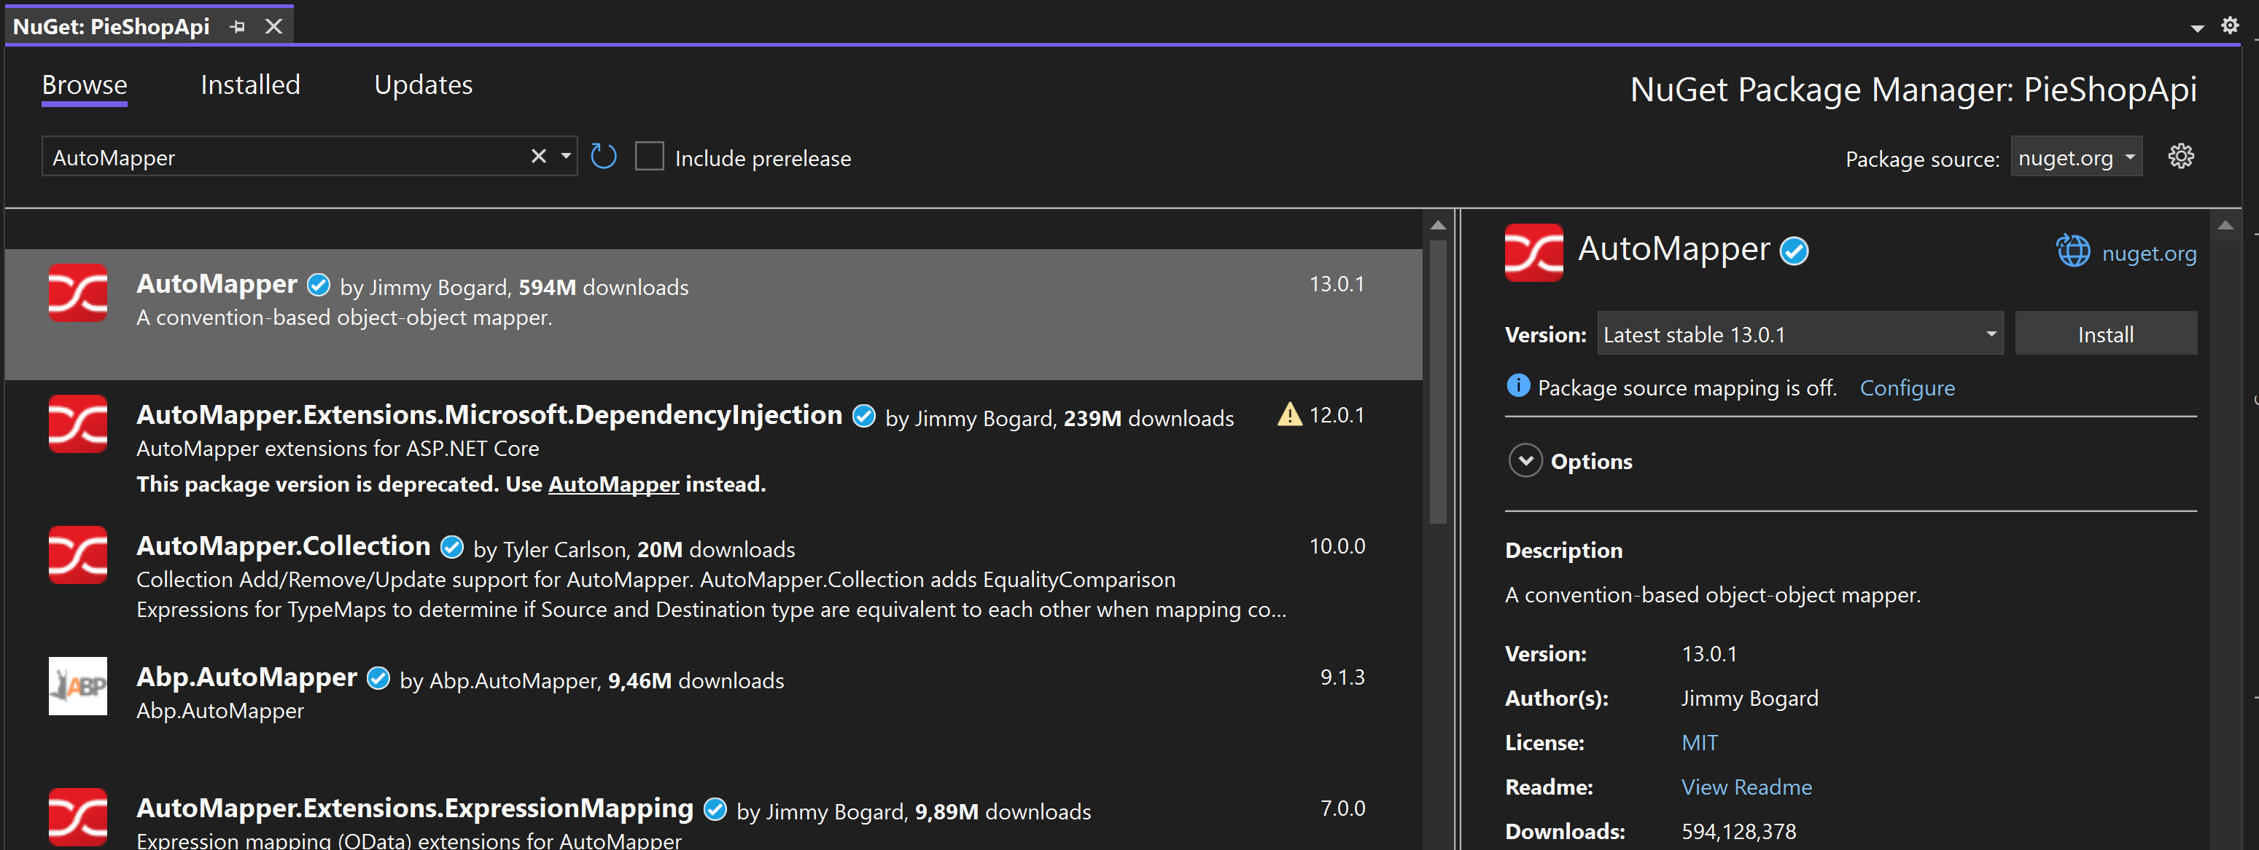
- In the Program.cs file, register AutoMapper as a service in our DI container
The argument tells AutoMapper to include all mapping Profiles present in this project
builder.Services.AddAutoMapper(Assembly.GetExecutingAssembly());
Mapping Profiles are the classes where you can specify how 2 objects can map to each other
e.g. Pie to PieDto
AutoMapper uses conventions to try and automatically map (hence the name), but you can also specify custom mapping logic (e.g. for aggregations).
- Using the Solution Explorer, let’s create a new folder in our project, called “Mappers”
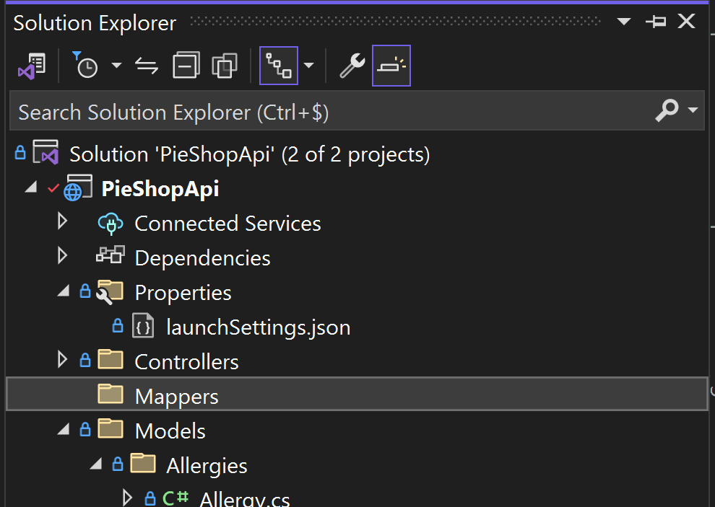
- To the Mappers folder, add a new class called PieProfiles.cs
Don’t forget to add a using statement for AutoMapper
Notice that we inherit from the Profile class
Notice that we do an aggregation to map from the List<Allergy> to the List<string>
Notice that most properties are mapped automatically
public class PieProfile : Profile
{
public PieProfile()
{
CreateMap<Models.Pies.Pie, Models.Pies.PieDto>()
.ForMember(dest => dest.AllergyItems, opt =>
opt.MapFrom(src => src.AllergyItems.Select(a => a.Name).ToList()));

CreateMap<Models.Pies.Pie, Models.Pies.PieForListDto>();

CreateMap<Models.Pies.PieForCreationDto, Models.Pies.Pie>();

CreateMap<Models.Pies.PieForUpdateDto, Models.Pies.Pie>();
}
}
- In our PieController, let’s inject AutoMapper using constructor injections
[ApiController]
[Route("pies")]
public class PiesController : ControllerBase
{
private readonly IPieRepository _pieRepository;
private readonly IMapper _mapper;

public PiesController(IPieRepository pieRepository, IMapper mapper)
{
_pieRepository = pieRepository;
_mapper = mapper;
}
// ...
}
- Update the GetPies method and verify using the .http file
[HttpGet]
public async Task<ActionResult<IEnumerable<PieForListDto>>> GetPies(int? size, int? page)
{
if ((size.HasValue && (size.Value <= 0 || size.Value > 50)) || (page.HasValue && page.Value <= 0))
{
return Problem(
title: "Bad Input",
detail: "Size, if provided, must be between 1 and 50. Page, if provided, must be greater than 0.",
type: "Paging_Error",
statusCode: StatusCodes.Status400BadRequest
);
}

if (size.HasValue && size.Value > 0 && (page.HasValue && page > 0 || !page.HasValue))
{
var pieListPaged = await _pieRepository.GetPagedReponseAsync(page ?? 1, size.Value);
return Ok(_mapper.Map<IEnumerable<PieForListDto>>(pieListPaged));
}

var pieList = await _pieRepository.ListAllAsync();

return Ok(_mapper.Map<IEnumerable<PieForListDto>>(pieList));
}
- Update the GetPie method and verify using the .http file
[HttpGet]
[Route("{id:int}")]
public async Task<ActionResult<PieDto>> GetPie(int id)
{
var pie = await _pieRepository.GetByIdAsync(id);

if (pie == null)
return NotFound();

var pieDto = _mapper.Map<PieDto>(pie);

return Ok(pieDto);
}
- Update the CreatePie method and verify using the .http file
[HttpPost]
public async Task<ActionResult<Pie>> CreatePie(PieForCreationDto pie)
{
var pieToAdd = _mapper.Map<Pie>(pie);

var createdPie = await _pieRepository.AddAsync(pieToAdd);

return CreatedAtAction(nameof(GetPie), new { id = createdPie.Id },
_mapper.Map<PieDto>(createdPie));
}
- Update the UpdatePie method and verify using the .http file
[HttpPut]
[Route("{id:int}")]
public async Task<ActionResult<Pie>> UpdatePie(int id, PieForUpdateDto pie)
{
var currentPie = await _pieRepository.GetByIdAsync(id);

if (currentPie == null)
return NotFound();

_mapper.Map(pie, currentPie);

await _pieRepository.UpdateAsync(currentPie);

return NoContent();
}

Managing our Pie-Allergies
Up until now, we have ignored the allergies part when creating or updating our Pies.
In this part we’ll fix that by creating a new controller specifically for that, which has the route “pies/{pieId}/allergies”.
Know that this is a design choice (and a good excuse to introduce the concept of idempotency ).
Steps:
- In the “Persistence” folder, create a new interface called “IAllergiesRepository.cs”
public interface IAllergyRepository : IAsyncRepository<Allergy>
{
}
- In the “Persistence” folder, create a new class called “AllergiesRepository.cs”
public class AllergyRepository : RepositoryBase<Allergy>, IAllergyRepository
{
public AllergyRepository(PieShopDbContext dbContext) : base(dbContext)
{
}
}
- Update the PiesRepository (and its interface), so that we have 2 extra methods to Add or Remove an Allergy from the Pie.
public class PieRepository : RepositoryBase<Pie>, IPieRepository
{
// ...

public async Task<Pie?> AddAllergyAsync(Pie pie, Allergy allergy)
{
pie.AllergyItems.Add(allergy);
await _dbContext.SaveChangesAsync();

return pie;
}

public async Task<Pie?> RemoveAllergyAsync(Pie pie, Allergy allergy)
{
pie.AllergyItems.Remove(allergy);
await _dbContext.SaveChangesAsync();

return pie;
}
}

public interface IPieRepository : IAsyncRepository<Pie>
{
Task<Pie?> GetByPartialNameAsync(string name);
Task<Pie?> AddAllergyAsync(Pie pie, Allergy allergy);
Task<Pie?> RemoveAllergyAsync(Pie pie, Allergy allergy);
}
- In the Program.cs file, register the newly created repository
builder.Services.AddScoped(typeof(IAllergyRepository),
typeof(AllergyRepository));
- In the PiesController, let’s name the route for GetPie, as we’ll use this later
[HttpGet]
[Route("{id:int}", Name = "GetPie")]
public async Task<ActionResult<PieDto>> GetPie(int id)
{
// ...
}
- In the “Controllers” folder, add a new class named “PieAllergiesController.cs” and inject dependencies for the PieRepository and the AllergyRepository
[ApiController]
[Route("pies/{pieId:int}/allergies")]
public class PieAllergiesController: ControllerBase
{
private readonly IPieRepository _pieRepository;
private readonly IAllergyRepository _allergyRepository;

public PieAllergiesController(IPieRepository pieRepository, IAllergyRepository allergyRepository)
{
_pieRepository = pieRepository;
_allergyRepository = allergyRepository;
}
// ...
}
- In the controller, add a new method for PUT, which we will use to add an allergy to a Pie
⁉️ Notice we’re using PUT here to add an allergy
Because we don’t want allergies to be added multiple times, we upsert (update or insert) them into the Pie, making the method idempotent.
(An alternative approach could be to update the entire allergy list for a given Pie in one call)
Notice the CreateAtRoute type, where we reference the route name for our GetPie method
[HttpPut]
[Route("{allergyId:int}")]
public async Task<IActionResult> Put(int pieId, int allergyId)
{
var pie = await _pieRepository.GetByIdAsync(pieId);
var allergy = await _allergyRepository.GetByIdAsync(allergyId);

if (pie == null || allergy == null)
{
return NotFound();
}

if (pie.AllergyItems.Contains(allergy))
{
return NoContent();
}

await _pieRepository.AddAllergyAsync(pie, allergy);

return CreatedAtRoute("GetPie", new { id = pieId }, null);
}
- In the controller, add a new method to DELETE an Allergy from the pie
[HttpDelete]
[Route("{allergyId:int}")]
public async Task<IActionResult> Delete(int pieId, int allergyId)
{
var pie = await _pieRepository.GetByIdAsync(pieId);
var allergy = await _allergyRepository.GetByIdAsync(allergyId);

if (pie == null || allergy == null)
{
return NotFound();
}

await _pieRepository.RemoveAllergyAsync(pie, allergy);

return NoContent();
}
- Let’s test both method using our .http file:
  - Let’s check that Pie with ID = 2 has no allergies
GET {{PieShopApi_HostAddress}}/Pies/2
  - Let’s add a pie 201-Created
PUT {{PieShopApi_HostAddress}}/Pies/2/Allergies/1
  - Let’s check if it was added
GET {{PieShopApi_HostAddress}}/Pies/2
  - Let’s try to add it again 204-No Content
  - Let’s delete the allergy
DELETE {{PieShopApi_HostAddress}}/Pies/2/Allergies/1
  - Let’s check if it was deleted
GET {{PieShopApi_HostAddress}}/Pies/2

Adding a Logging Filter
To demonstrate the use of Action Filters, we’ll implement a simple console logger that logs how long an action takes to execute.
Note that this is an example on using Action Filters and that for real-world scenarios, you’d use a logging framework to implement this.
Steps:
- Let’s start by creating a new folder in our project, called “Filters”
- Inside the “Filters” folder, let’s create a new class called “LoggingFilterAttribute”
Notice that we’re using an async action filter that allows to execute code before the action executes (before the next() delegate) and after it has executed (after the next() delegate)
public class LoggingFilterAttribute : ActionFilterAttribute
{
public override async Task OnActionExecutionAsync(ActionExecutingContext context, ActionExecutionDelegate next)
{
var url = context.HttpContext.Request.Path.Value;
Console.WriteLine($">>>>> Start excuting action on route {url}");
var stopwatch = Stopwatch.StartNew();

await next();

stopwatch.Stop();
Console.WriteLine($">>>>> Finished excuting action on route {url} in {stopwatch.ElapsedMilliseconds}ms");
}
}
- Let’s test our Logging filter by using it on the GetPies method of our PiesController
[HttpGet]
[LoggingFilter]
public async Task<ActionResult<IEnumerable<PieForListDto>>> GetPies(int? size, int? page)
{
//...
}
- Launch the application and executes the GetPies method using the .http file
GET {{PieShopApi_HostAddress}}/pies
- Look for the log messages in the console
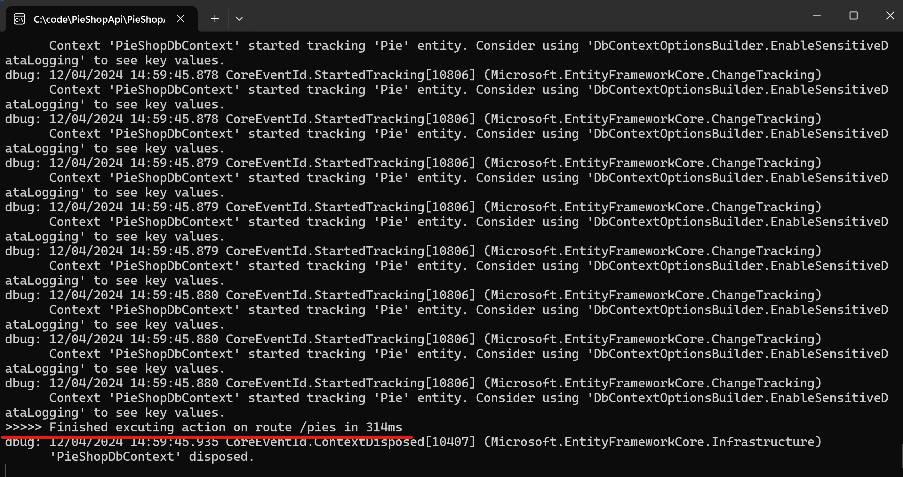
- Let’s move the Attribute to the PiesController
(Remove it from the GetPies method)
[ApiController]
[Route("pies")]
[LoggingFilter]
public class PiesController : ControllerBase
{
// ...
}
- Test other methods of the PiesController they also get logged now
- Remove (or comment out) the Attribute from the PiesController
- In the Program.cs file, let’s provide options to the AddControllers extension method, to register the filter for all controllers in our project
Notice that we already call the AddControllers extension method, so we use the overload to provide options instead.
builder.Services.AddControllers((options) =>
{
options.Filters.Add<LoggingFilterAttribute>();
});
- Test the methods of the PieAllergiesController they also get logged now

No Allergies vs no Allergy information
Our seeded data contains Pies without any allergy items on them.
For our consumers, this might be confusing:
- Are there no allergy items for this Pie?
- Are there allergy items, but is the information not provided?
Let’s extend our application to make this explicit.
In this part we’ll implement this logic using a Result Filter.
Result Filters execute after the action was successfully executed, but allow us to implement logic before and/or after the result has been executed.
Steps:
- In our PieShopDbContext, let’s seed a new Allergy value “None” and create a new Pie that uses it
override protected void OnModelCreating(ModelBuilder modelBuilder)
{
modelBuilder.Entity<Allergy>().HasData(
new Allergy { Id = -1, Name = "None" },
new Allergy { Id = 1, Name = "Cow's milk" },
new Allergy { Id = 2, Name = "Eggs" },
new Allergy { Id = 3, Name = "Tree nuts" },
new Allergy { Id = 4, Name = "Peanuts" },
new Allergy { Id = 5, Name = "Shellfish" },
new Allergy { Id = 6, Name = "Wheat" },
new Allergy { Id = 7, Name = "Soy" },
new Allergy { Id = 8, Name = "Fish" },
new Allergy { Id = 9, Name = "Sesame" }
);

modelBuilder.Entity<Pie>().HasData(
new Pie { Id = 1, Name = "Apple Pie", Description = "Tasty" },
new Pie { Id = 2, Name = "Cherry Pie", Description = "Yummy" },
new Pie { Id = 3, Name = "Pumpkin Pie", Description = "Delicious" },
new Pie { Id = 4, Name = "Blueberry Pie", Description = "Scrumptious" },

// ...
new Pie { Id = 51, Name = "Vegan & Gluten-Free Apple Pie", Description = "Allergy free" }
);

modelBuilder.Entity<Pie>()
.HasMany(p => p.AllergyItems)
.WithMany(a => a.Pies)
.UsingEntity(p => p.HasData(
new { PiesId = 1, AllergyItemsId = 1 },
new { PiesId = 1, AllergyItemsId = 2 },
new { PiesId = 1, AllergyItemsId = 6 },
new { PiesId = 51, AllergyItemsId = -1 }
));

base.OnModelCreating(modelBuilder);

}
- In the “Filters” folder, add a new class called PieAllergyFilterAttribute
public class PieAllergyFilterAttribute : ResultFilterAttribute
{
public override async Task OnResultExecutionAsync(ResultExecutingContext context, ResultExecutionDelegate next)
{
if (context.Result is ObjectResult objectResult)
{
if (objectResult.Value is PieDto pieDto)
{
if (pieDto.AllergyItems.Count == 0)
{
pieDto.AllergyItems.Add("No info available");
}
}
}

await next();
}
}
- In the PiesController, add the filter to the GetPie method
[HttpGet]
[PieAllergyFilter]
[Route("{id:int}", Name = "GetPie")]
public async Task<ActionResult<PieDto>> GetPie(int id)
{
var pie = await _pieRepository.GetByIdAsync(id);

if (pie == null)
return NotFound();

var pieDto = _mapper.Map<PieDto>(pie);

return Ok(pieDto);
}
- Let’s test the result using our .http file
  - GET a pie without allergy info shows “No info available”
GET {{PieShopApi_HostAddress}}/Pies/2
  - Get a pie with a “None” allergy item shows “None”
GET {{PieShopApi_HostAddress}}/Pies/51

Adding an Audit trail to the Database
In this part we’re going to audit the management of allergy information on the Pies API, by storing changes in the Database.
Note that in a real-world scenario you’d use the auditing functionality of your database; this again is for demo purposes.
Should be as simple as the LoggingFilterAttribute, right?
Wrong! As we have a dependency on the database, which we want to inject into our filter for separation of concerns, we can’t add the attribute directly to the controller.
Luckily we can use TypeFilters for this.
Steps:
- Let’s add a new entity called “AuditEntry” in our “Filters” folder
public class AuditEntry
{
public AuditEntry(string message)
{
Message = message;
CreatedAt = DateTime.Now;
}
public int Id { get; set; }

public string Message { get; set; }

public DateTime CreatedAt { get; set; }
}
- In the PieShopDbContext, add the property DbSet of type AuditEntry
public class PieShopDbContext : DbContext
{
public PieShopDbContext(DbContextOptions<PieShopDbContext> options) : base(options)
{
}

public DbSet<Pie> Pies { get; set; }
public DbSet<Allergy> Allergies { get; set; }

public DbSet<AuditEntry> AuditEntries { get; set; }
// ...
}
- In the “Filters” folder, create a new file called AuditFilter
Notice we inject the DbContext
public class AuditFilter : IAsyncActionFilter
{
private readonly PieShopDbContext _dbContext;

public AuditFilter(PieShopDbContext dbContext)
{
_dbContext = dbContext;
}

public async Task OnActionExecutionAsync(ActionExecutingContext context, ActionExecutionDelegate next)
{
await next();

var body = System.Text.Json.JsonSerializer.Serialize(context.ActionArguments);

var auditEntry = new AuditEntry($"{context.HttpContext.Request.Method} - {context.HttpContext.Request.Path} - {body}");

await _dbContext.AuditEntries.AddAsync(auditEntry);
await _dbContext.SaveChangesAsync();
}
}
- Apply the filter on the PieAllergyController
[ApiController]
[Route("pies/{pieId:int}/allergies")]
[TypeFilter(typeof(AuditFilter))]
public class PieAllergiesController: ControllerBase
{
// ...
}
- Test adding and deleting Allergies to and from Pies using the .http file
PUT {{PieShopApi_HostAddress}}/Pies/2/Allergies/1
- Watch the console, where we print the queries to the database and notice our audit in action
